**SQl Server Project test and documentation**

**Team Members :**

**Mustafa Mohmmed Zayd**

**Abanoub Ibrahim Marzouk**

**Mahmoud Mohmmed Mahmoud**

**ERD ScreenShot :**

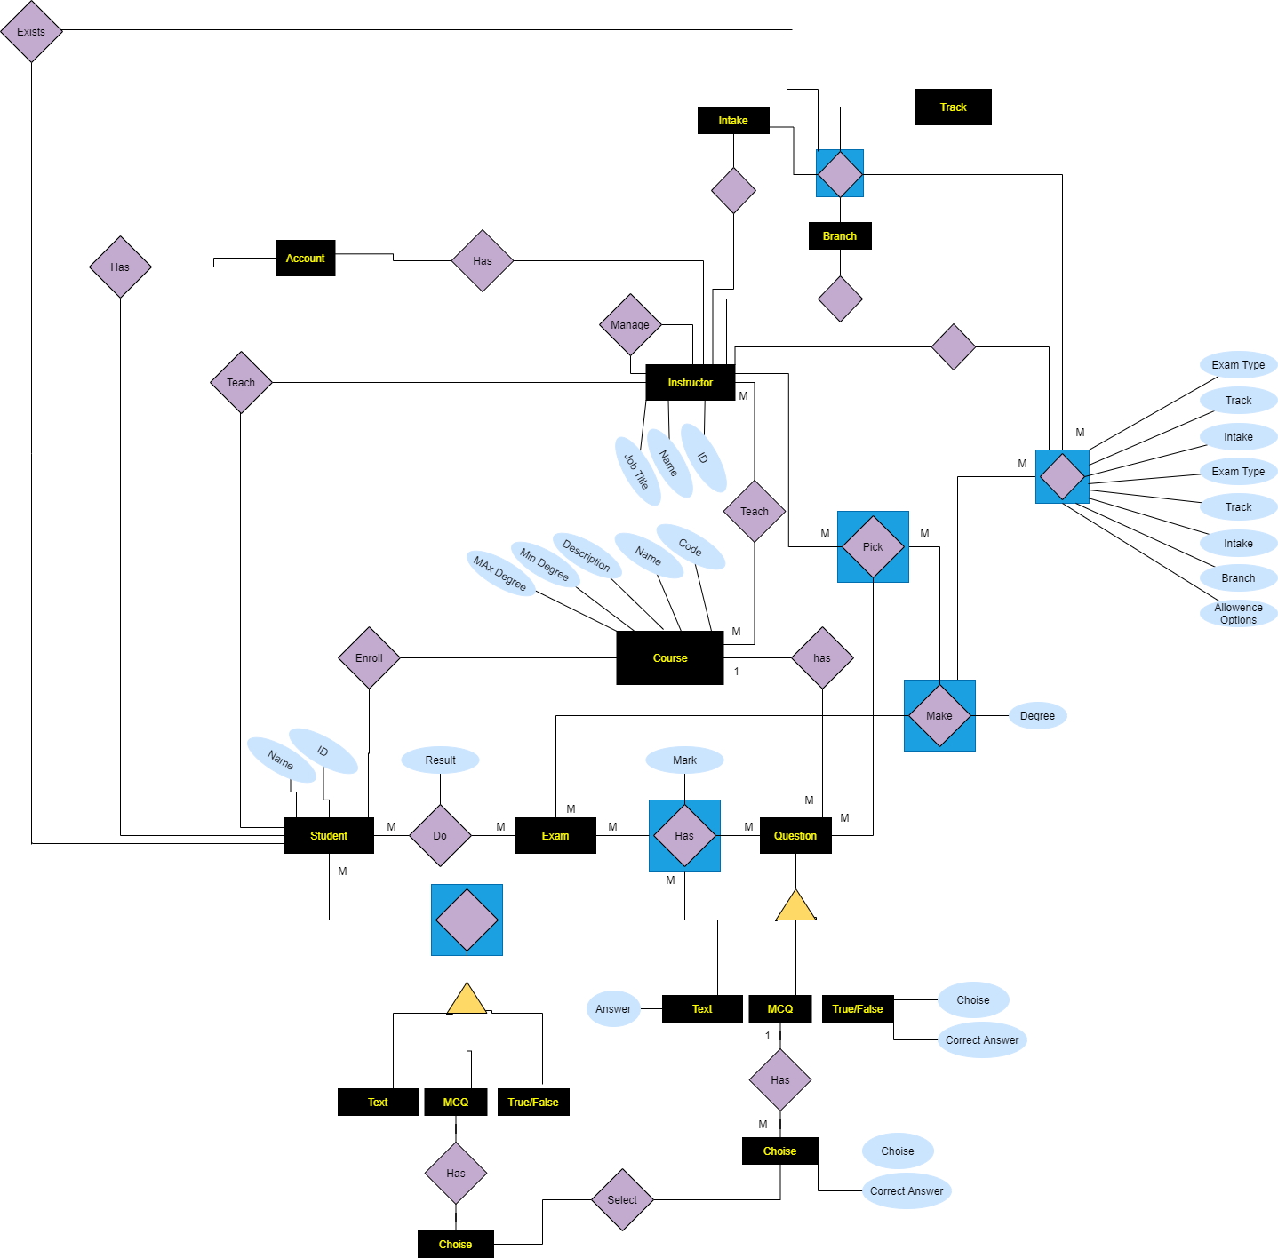

|  |  |  |  |  |  |
| --- | --- | --- | --- | --- | --- |
| **Object**  **type/ Name** | **Description** | **Parameters List** | **Test Query**  **(Execute)** | **Comment** | **Developed By** |
| Procedure | Show All Student Names Who Enroll In Each Course By Course Code | @courseCode varchar(3) | Declare @CourseCode varchar(3)  set @CourseCode='MVC';  exec ShowAllStudentNamesWhoEnrollInEachCourseByCourseCode @CourseCode; |  | Mustafa |
| Procedure | Show ExamType(Name) and instructor name who put this Exam in an Branch by BranchID | @BrachID int | Declare @BranchID int  set @BranchID=2;  exec ShowExamTypeAndInstructorNameWhoPutThisExamInAnBranchByBranchID @BranchID; |  | Abanoub |
| Procedure | show ExamType(Name) and its questions and mark of each question by ExamID | @ExamID int | Declare @ExamID int  set @ExamID=2;  exec ShowExamTypeanditsquestionsbyExamID @ExamID; |  | Mahmoud |
| Procedure | Show All Students Who Do This Exam | @ExamID int | Declare @ExamID int  set @ExamID=2;  exec ShowAllStudentsWhoDoThisExam @ExamID; |  | Mustafa |
| Procedure | show all courses that teach by an insructor by insert isnstructor id | @InstructorID int | declare @InstructorID int  set @InstructorID=1;  exec CourseNameWhichInsructorTeachIt @InstructorID; |  | Abanoub |
| Procedure | Add Text Questions by Insructor to the course which he teach it | @AccountID int,@CourseCode varchar(3),@QText varchar(255),@QuestionID int , @Answer nvarchar(255),@TextQuestionID int | declare @AccountID int  Declare @CourseCode varchar(3)  declare @Qtext varchar(255)  declare @QuestionID int  declare @Answer varchar(255)  declare @TextQuestionID int  set @AccountID=2  set @CourseCode='MVC'  set @Qtext='What is MVC text Question texst'  set @QuestionID=32  set @Answer='AnswerQ13'  set @TextQuestionID=13  exec AddTextQuestion @AccountID, @CourseCode , @Qtext , @QuestionID , @Answer , @TextQuestionID; |  | Mustafa |
| View | Show All Students who do an exam an each Text Question in this exam and its model answer and its mark and student answer on it and student mark for each Question | NO | select * from ShowTQwithStudentAnswer |  | Abanoub |
| View | Show All Students who do an exam an each True or False Question in this exam and its model answer and its mark and student answer on it and student mark for each Question | NO | select * from ShowTFQwithStudentAnswer |  | Mahmoud |
| Procedure | Add True False Questions by Insructor to the course which he teach it | @AccountID int,@CourseCode varchar(3),@QText varchar(255),@QuestionID int , @Answer nvarchar(50),@TFQuestionID int | declare @AccountID int  Declare @CourseCode varchar(3)  declare @Qtext varchar(255)  declare @QuestionID int  declare @Answer varchar(50)  declare @TFQuestionID int  set @AccountID=2  set @CourseCode='MVC'  set @Qtext='What is MVC TESTTTTT'  set @QuestionID=31  set @Answer='True'  set @TFQuestionID=10  exec AddTrueorFalseQuestion @AccountID, @CourseCode , @Qtext , @QuestionID , @Answer , @TFQuestionID | **Please note : all IDs is Primary Key , Test using ID Not exists** | Mustafa |
| Procedure | Exam Result at specific student and Exam total mark | @ExamID int , @StudentID int , @Result int output , @TotalMarksOfExam int output | declare @ExamID int  Declare @StudentID int  declare @Result int  declare @TotalMarksOfExam int  Set @ExamID=1;  set @StudentID=1;  exec Result @ExamID, @StudentID , @Result output , @TotalMarksOfExam output  Select str(@Result) As 'Student Result in Exam' , str(@TotalMarksOfExam) AS 'Total Marks Of Exam' |  | Abanoub |
| Procedure | Return Student Degree of Specific Question | @ExamID int , @StudentID int , @QuestionPoolID int, @TotalMarks int output | declare @ExamID int  Declare @StudentID int  Declare @QuestionPoolID int  declare @TMarks int  Set @ExamID=1;  set @StudentID=5;  set @QuestionPoolID=12;  exec Degree @ExamID, @StudentID , @QuestionPoolID, @TMarks output  Select str(@TMarks) |  | Mustafa And Mahoud |
| Procedure | Show Total Marks of Student in Text Question in Exam | @StudentID int , @TotalMarks int output | declare @TMarks int  declare @SID int  Set @SID=2  exec ShowTotalMarksofStudentinTQinExam @SID, @TMarks output  Select str(@TMarks) + ' Total marks in TextQ int theexam for this student' |  | Abanoub And Mahmoud |